CHARLES AFRIYIE

THE ROLE OF CALCULUS IN ARTIFICIAL INTELLIGENCE AND ITS USE IN FINANCE

ARTIFICIAL INTELLIGENCE (FT206)

Eke, Oluwafemi

[Year]

# CHAPTER ONE

## WHAT IS THE ROLE OF CALCULUS IN ARTIFICIAL INTELLIGENCE ALGORITHM?

#### INTRODUCTION

Artificial intelligence has grown over the years due to the availability of large dataset and improved computer infrastructure. This has caused the amelioration of its application and definition in which tasks such as optical character recognition is not considered as AI anymore. It Being imbedded in everyday technology is now responsible for the fast development experienced in our modern day, from understanding human language through natural language processing to being used in the development of self-driving cars. AI does not only encompass computer science but other fields such as psychology, philosophy, statistics, economics, and mathematics. Mathematical concepts such as linear algebra, probability, and calculus are responsible for the development of AI. Mathematics application through calculus is a dynamic enactment that has not only laid foundation for future growth and development in the field of AI but has presently increased the functions and ability of AI in areas such as machine learning and deep learning. This study seeks to elucidate the role of calculus in artificial intelligence and its application.

#### DEFINITION OF CONCEPTS

##### CALCULUS

The concept of calculus has evolved over time from what its original Latin meaning ‘’small pebble’’. The modern discovery of this concept is widely attributed to Newton and Leibniz, who are responsible for developing calculus and its notations. Calculus is a branch of maths that studies the behaviour of functions as they approach infinity and the relationship between derivative, integral and limit (The Great Courses, 2016). Calculus has been applied in different fields, such as statistics, economics, architecture, engineering, research analysis, space science, pharmacology, electronics, and physics. It is made of two branches, differential calculus, and integration calculus. Differential calculus studies the rate of change of a function with respect to its variables, while Integration calculus studies differential calculus, which is the quantity when the rate of change is known (Russell, 2004). Differential and integral calculus deals with curve and the area under the curve (Russell, 2004). There are rules that are used by these branches, such as differential rules and integration rules. Differential laws include product, quotient, and chain rule while integration rules are partial fraction decomposition, integration by parts and u-substitution. Variables are classifed as either dependent or independent while Integration is further divided into two parts, definite and indefinite integral.

##### ARTIFICIAL INTELLIGENCE

Intelligence is the ability to collect data, adapt to data and use such knowledge to complete tasks in an effective and efficient way. AI is defined as machine that perform cognitively like humans in terms of learning, perceiving and problem solving (Horrell & Helin, 2021). It is the use of computers to understand human intelligence, but it does not necessarily restrict itself to biological observable methods (McCarthy, 2004). The concept AI was introduced by Alan Turing after the WW11 in his paper ‘’ Computing Machinery and Intelligence’’ and developed what is known as Turing test which was used to test if AI can demonstrate human intelligence. John Mcarthy coined the term Artificial Intelligence in a proposed conference called at Dartmouth College and the first AI software was created later that year. In 1969 Frank Rosenblatt builds a computer called Mark 1 Perceptron that operates using a neural network and later a landmark literature in neural network called Perceptrons was written by Marvin Minsky and Seymour Papert. The application of AI grew over time as research and development increased, such application includes customer service, recommendation engine, speech recognition, computer vision, fraud detection and automated stock trading. There are two types of AI, weak and strong AI. Weak AI also called Artificial Narrow Intelligence are designed to specifically accomplish certain task, examples are Apple Siri and Amazon Alexa. Strong AI consist of Artificial General Intelligence and Artificial Super Intelligence, which is designed to accomplish more complex task. It is built to be self-aware and process data faster than the human mind. It is purely theoretical with no practical proof in modern day (IBM, 2020). AI can further be classified into reactive AI, limited memory AI, theory of mind AI and self-aware AI (Frankenfield, 2016).

##### ARTIFICIAL INTELLIGENCE ALGORITHM

Algorithm is a set of instruction given to a computer to perform certain functions. The main goal of AI algorithm is to enable the computer to learn on its own. Algorithm is a vital aspect in the structure of AI, whereby simple application uses simple algorithm and complex algorithms are used to frame strong AI (Frankenfield, 2016). It is classified into Regression algorithm, Clustering algorithm and classification algorithm. Regression algorithm uses supervised learning to forecast or predict future outcomes based on given input, examples are Linear regression, gradient boosting, and random forest. Classification algorithm also uses supervised learning to classify inputted data and make predictions or decisions based on these classes., examples are Naïve Bayes, logistic regression, support vector machine and decision tree. Clustering algorithm uses unsupervised learning approach to group data set based on similarities and differences, examples are fuzzy c-means Algorithm, k-means clustering and hierarchical clustering.

#### THE ROLE OF CALCULUS IN ARTIFICIAL INTELLIGENCE

##### GRADIENT DESCENT

This is used in machine learning to upgrade parameters in models, such as weights in neural networks and coefficients in linear regression. It is an optimization algorithm used to minimize functions by repetively moving in the direction of the steepest descent determined by the negative of the gradient.

##### COST FUNCTION

It is a function used to evaluate the model prediction by calculating the difference between the predicted value and the actual value to quantify the error which is presented as a single number.

##### OPTIMIZATION

It is a function or algorithm used to train the model or neural network to be more accurate by modifying the weight, using the loss function as a guide in determining the right or wrong direction, examples include Adagrad, Adadelta, Adam Conjugate Gradients, BFGS, Momentum, Nesterov Momentum, Newton’s Method, RMSProp and SGD.

##### FORWARD PROPAGATION AND BACKWARD PROPAGATION

Forward propagation is the method used by neural networks to make predictions; it propagates from the input layer to the hidden layers then to the output layer, which takes more time in minimizing the loss function compared to the backward propagation which moves from the output layer to the hidden layers and then to the input layer, and it is used to minimize the loss function by adjusting the weight and the bias in an iterative process till the optimal solution is reached..

##### NEURAL NETWORK

Neural network creation is based on the human brain and is expected to mimic the human brain. It consists of a wide network of input layers, hidden layers that outputs a result from the combination of all inputs. It involves the forward and backward propagation which is used as a feedback system with which the system or computer learns and minimize the loss function. Neural network is a subset of ML used to observe complex patterns in a dataset using nonlinear activation functions and hidden layers. Deep learning is a neural network made up of multiple layers that attempt to simulate the human brain and learns from available large set of data..

##### LEARNING

AI learning is the use of inputs to predict an output of future input. Artificial Intelligence learning consist of machine line and deep learning, which are all subset of each other. Machine learning is the ability o a computer to use past data or input to adapt, learn, develop, and make predictions with minimal human intervention. The emergence of big data and IOT (internet of things) makes it possible to extract specific data from large data set for the purpose of learning from it in iterative way without the intervention of humans. There are three types of ML used in AI, which are supervised, unsupervised, semi supervised and reinforcement learning. Supervised learning involves the use of labelled inputs to train, in order to predict an output. Unsupervised learning involves the use of unlabelled inputs to train by finding patterns in the input dataset to predict the output. Semi supervised learning involves the use of both labelled and unlabelled inputs to predict the output. Reinforcement learning is a reward or feedback approach to learning, which involves the use of experience instead of labelled inputs learning. This has minimal human intervention as it trains itself using algorithm designed in achieving maximum rewards in which it is rewarded for getting the test right or predicting correctly and is punished for getting it wrong. It is further divided into positive and negative reinforcement learning.

##### DERIVATIVE

It is defined as the slope of a line at a specific point, or it is used to calculate instantaneous rate of change of a variable with respect to the change of another variable.

##### PARTIAL DIFFERENTIATION

This is the use of calculus in machine learning to find the minimal and the maximum of the function. This is finding the derivative of a variable with respect to another variable. It calculates the rate of change of a function with respect to a variable.

##### CHAIN RULE

This is a differential rule of calculus used in calculating the derivatives of composite functions, which are functions nested in a function.

##### DOT PRODUCT

This is a mathematical function used to calculate the weighted sum in an activation function of a neural network.

##### ACTIVATION FUNCTION

This decided the activation of a neuron or not by mathematically calculating the sum of the weight and the bias. This function is used to transform the neural network from a linear regression model to non-linear so it can perform complex tasks. There are several types of activation functions such as Linear, ELU, ReLU, LeakyReLU, Sigmoid, Tanh and SoftMax.

##### CONCLUSION

Neural network is simply the mapping of input to output and it uses calculus in its loss function and function optimization through gradient decent. Gradient decent algorithm decides how to adjust the weights to reduce the error iteratively. Calculus through its dynamic characteristic is used to solve complex functions and optimization tasks. Calculus is also applied in neural network using partial derivative to adjust the weights iteratively as needed, to reach the minimum function.

# CHAPTER TWO

## EVIDENCE

#### INTRODUCTION

Artificial intelligence through calculus solves diverse problems in different fields, especially in the financial sector. AI booming growth which is the epitome of the 4th industrial revolution is being embraced in the financial sector regardless of the slow pace of regulation and security in catching up. Artificial intelligence because of its capacity to solve underlying issues is being used in different areas like asset management, credit under-writing, algorithm trading through AI application in risk management, risk assessment, credit decisions, trading, making smart underwriting decisions, process automation, reduction in human error, preventing cyberattacks, Financial advisory services, executing bulky tasks, fraud detection, management and prevention. The availability of data and increased computational power gave room for AI to solve more complex issues. Machine learning uses this large set of data ((big data) to improve in performance and predictability automatically without the involvement of humans. This development in machine learning is responsible for the emergence of neural network and deep learning. Neural network is created with the effort of mimicking the human brain. Neural network is a type of machine learning language that makes use of nodes or neuron in a layered format to map inputs and outputs using mathematical principles. Artificial intelligence capabilities range from machine learning, deep learning, natural language processing, text mining to natural language generator. The capability of AI seems endlessly amazing to some while looking scary like the world’s doom to others. Same goes for its applications, but this section focuses on the use of AI in finance multivariate time series LSTM to forecast the share price of four companies across four industries.

#### RESEARCH QUESTION

What is the use of Artificial intelligence in finance?

#### RESEARCH OBJECTIVE

The use of artificial intelligence in forecasting

#### METHODOLOGY

This study seeks to answer the research question by achieving the research objective using multivariate time series data gotten from Refinity that covers 22 years from 2010 to 2022. This data entails the share price of four different companies across four different industries. This companies include Saintsbury, Mercedes Benz, Vodafone, and Toyota. Saintsbury is one of the largest retail companies in the United Kingdom. Sony is a conglomerate known in the film, music video game, media and electronic appliances sectors. Vodafone is a multinational British telecommunication company. Toyota is a large Japanese automotive manufacturing company. This study seeks to use multivariate time series LSTM model to forecast the share prices of the four companies for a period of 365 days.

#### FORECASTING

The ability to forecast do not only give an edge in wars but also in business and finance. It can help in hiring decisions, inventory management, production management to meet market demand and exhaust consumer surplus, for forecasting revenue from sales and for making investment decisions. Due to the avalaibility of large data, through ML computers can train themselves using this large data by finding patterns, adapting and forecasting in an iterative way without the intervention of human. Some of the applications of ML in forecasting include stock price forecasting, web traffic forecasting, demand and sales forecasting, demographic and economic forecasting, climate, and weather forecasting. Forecasting is defined as using previous and past data especially trend analysis to make predictions about the future (Abbas, 2021). ML models uses this available large data set to make accurate predictions. This is a huge leap in forecasting, but these models come with their own share of concerns even after being able to address seasonality and trend issues, these models may encounter overfitting issues and under fitting issues (Abbas, 2021). ML methods gains prominence as interest in AI rises over time. They are used to predict financial time series , the direction of the stock market, macro-economic variables, accounting balance sheet information and a sizeable number of other applications, covering a wide range of areas (Makridakis et al., 2018). Time series which is defined as observable data collected by a system over a period (Piluta, 2021) is also used for forecasting based on the knowledge of the past. Before the modern rush for application of ML in forecasting some other models were used for forecasting which are called statistical forecasting models, this includes autoregressive integrated moving average (ARIMA), autoregressive integrated moving average with explanatory variable (ARIMAX) and linear regression. While Machine learning models used in forecasting include Artificial neural network, Gaussian processes, Classification and regression trees (CART), Long short-term-memory-based neural network, Random forest, Generalized regression neural networks, K-nearest neighbours regression and Support vector regression. This study makes use of the Long short-term memory-based forecasting model in predicting future share prices.

#### LSTM

Long Short-Term Memory (LSTM) is a particular type of recurrent neural network (RNN) architecture that was made to model temporal sequences and their long-range dependencies more accurately than conventional RNNs (Sak et al, 2014). Long Short-Term Memory is good in terms of remembering information and it becomes a good choice when handling much information because too much information affects the accuracy of the prediction. Typical LSTM module called repeating module has four neural network layers interacting in a unique fashion (Kumar, 2018). In an LSTM model a scaling method is used to reduce computational power consumption and the time taken to produce results. When interpreting a LSTM model result, it is important to note that the training loss being higher than the validation loss signifies underfitting while the training loss being lower than the validation loss signifies overfitting.

Sak et al (2015) did a research on Long short-term memory recurrent neural network architectures for large scale acoustic modelling. They introduced the first distributed training of LSTM RNNs using asynchronous stochastic gradient descent optimization on a large cluster of machine. They proved that the proposed deep LSTM RNN architecture outperforms standard LSTM networks and DNNs and makes more effective use of the model parameters by addressing the computational efficiency needed for large networks training and proved also that LSTM RNN models training is done quickly using ASGD distributed training

Kumar et al (2017) in their article ‘’ Long Short Term Memory Recurrent Neural Network Based Workload Forecasting Model for Cloud Datacentres’’ tackled the issues in cloud datacentre through workload prediction, using LSTM to develop a predictive model which showed high accuracy in predictions by reducing the mean squared error up to 3.17 × 10^3. They concluded that this predictive model helps in promoting green computing and smart resource scaling decisions.

#### FINDINGS

In figure 1a. Sony forecast of share price for over 365 days period shows a peak of 13500 and bottomed out and fell below 10000 open share price in November but recovered sharply between November and December. This forecast predicts an upward trend in share price which stands as an investment opportunity. Figure 1b signifies the model overfitting to the training data and this may not include unseen data in its forecasting.

According to figure 2a, LSTM model predicts a peak of 310 in January of Saintsbury open share price and a gradual decline till October below 180 which is an all-time low but rapidly increased in November. Figure 2b shows that the model may not be able to capture the complexity of the data due to underfitting.

Toyota share price is predicted to experience a sharp increase in open share price as seen in figure 3a with a peak in April at 2300 and a dip in June at 1900. The predicted steady decline is a warning to investors. Figure 3b shows proof of underfitting which indicate the model overgeneralizing and not including relevant data.

Figure 4a shows a turbulence in Vodafone open share price from December 2022 to May 2023 where there is a jump in open share price. From August a rapid decline is experienced, this predicts Vodafone to be a wrong choice of investment for investors. Figure 4b indicates underfitting, that the model is unable to cover the complexity of the data.

# CONCLUSION

This study answers the research question and fulfils its objective by applying Artificial intelligence in finance, using LSTM for multivariate time series forecasting. LSTM is widely known for its ability to process and predict using time series data. It was developed to solve the vanishing problem posed in RNN. It is preferred to others based on its relative insensitivity to gap lengths. Artificial intelligence is a fast growing mainstream technology acting as the centre of the 4th industrial revolution. LSTM was able to predict share of four companies across four industries which proves that LSTM is a suitable ML predictive tool for forecasting multivariate time series data. In the future a research based on the comparison of forecast comparators will be conducted, to know the best forecasting tool suited for forecasting share price across industries.

# REFERENCES

1. Abbas, O. (2021). Forecasting with Machine learning. *Neural Network Forecasting*.
2. Ahmed, N. K., Atiya, A. F., Gayar, N. E., & El-Shishiny, H. (2010). An Empirical Comparison of Machine Learning Models for Time Series Forecasting. *Econometric Reviews*, *5–6*, 594–621. https://doi.org/10.1080/07474938.2010.481556
3. Frankenfield, J. (2016, August 23). *Artificial Intelligence: What It Is and How It Is Used*. Investopedia; Investopedia. https://www.investopedia.com/terms/a/artificial-intelligence-ai.asp
4. Horrell, G., & Helin, H. (2021). The defining moment for data scientists. *Artificial Intelligence and Machine Learning Ready to Change Finance*.
5. IBM. (2020). *What is Artificial Intelligence (AI)?  | IBM*. IBM - United States. https://www.ibm.com/cloud/learn/what-is-artificial-intelligence
6. Makridakis, S., Spiliotis, E., & Assimakopoulos, V. (2018). Statistical and Machine Learning forecasting methods: Concerns and ways forward. *PLOS ONE*, *3*, e0194889. https://doi.org/10.1371/journal.pone.0194889
7. McCarthy, J. (2004). *WHAT IS ARTIFICIAL INTELLIGENCE?*
8. Piluta, R. (2021, October 27). *How to Use Machine Learning (ML) for Time Series Forecasting – NIX United*. NIX United – Custom Software Development Company in US; https://www.facebook.com/nixunited/. https://nix-united.com/blog/find-out-how-to-use-machine-learning-for-time-series-forecasting/
9. Rock content. (2021, June 28). *What are Artificial Intelligence Algorithms and How do they work*. Rock Content; https://www.facebook.com/werockcontent. https://rockcontent.com/blog/artificial-intelligence-algorithm/
10. Russell, D. (2004, January 11). *What Is Calculus? Definition and Practical Applications*. ThoughtCo; ThoughtCo. https://www.thoughtco.com/definition-of-calculus-2311607
11. The Great Courses. (2016, December 15). *Who Invented Calculus - Newton or Leibniz? Learn the History of Calculus*. Wondrium Daily; https://www.facebook.com/TheGreatCourses/. https://www.wondriumdaily.com/invented-calculus-newton-leibniz/#:~:text=Sir%20Isaac%20Newton%20was%20a,had%20part%20of%20the%20idea.

# APPENDIX

Figure 1a

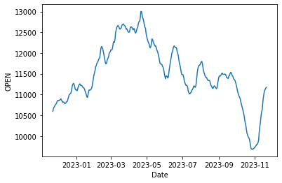

Figure 1b

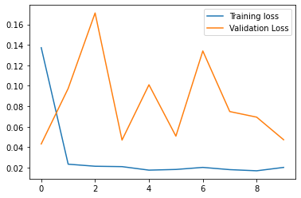

Figure 2a

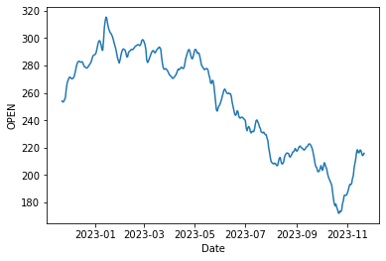

Figure 2b

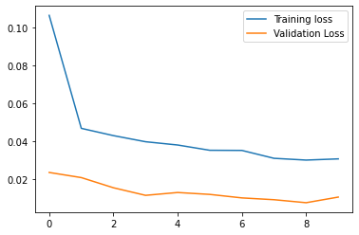

Figure 3a

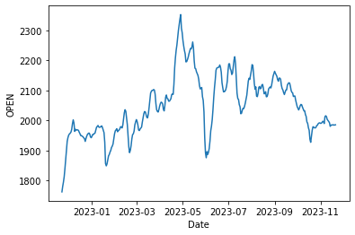

Figure 3b

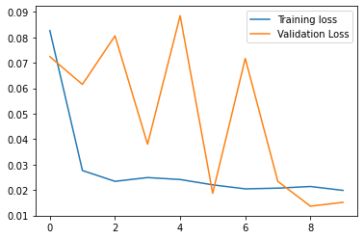

Figure 4a

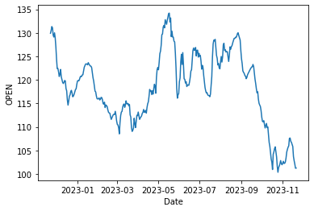

Figure 4b

